**Group Project Research:**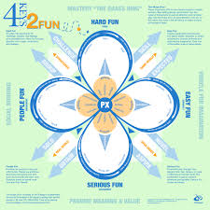

**Core game focuses:**

* *Competitive turn based gameplay.*
* *Single input, single device.*
* *Symmetrical level design and symmetric and balanced gameplay.*

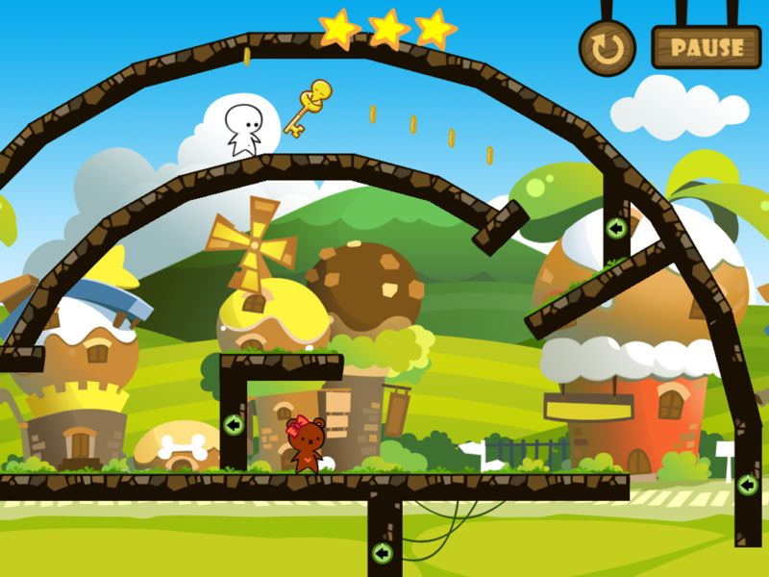

Reference and example:

Nicole Lizzaro’s Four Keys to Fun - Hard Fun, competitiveness, strategy, mastery of the gameplay mechanics.

Single Input: Tapping the phone’s screen.

Single Tap Movement - Flappy Bird controlling the ascending and descending of the character.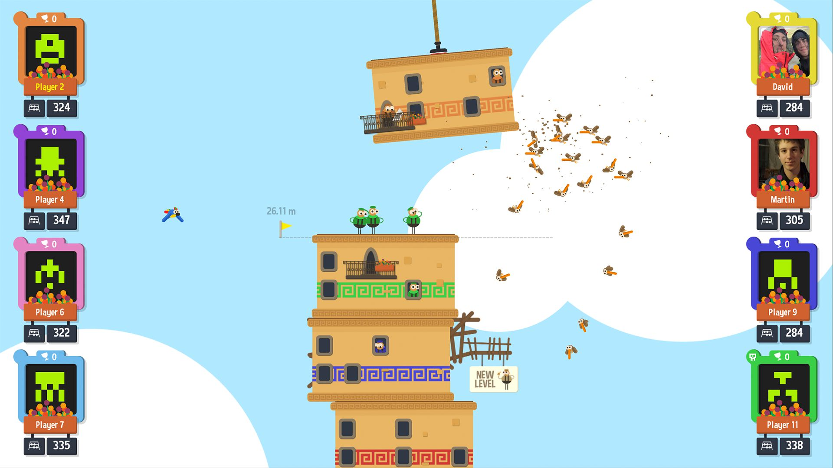

Single Tap to jump - One Tap Heroes, used to make the player jump. Timed with the level and platforms.

Single Input used to place something (Tower of Babel), used to place a tower block down.

Single Input to move things, etc…

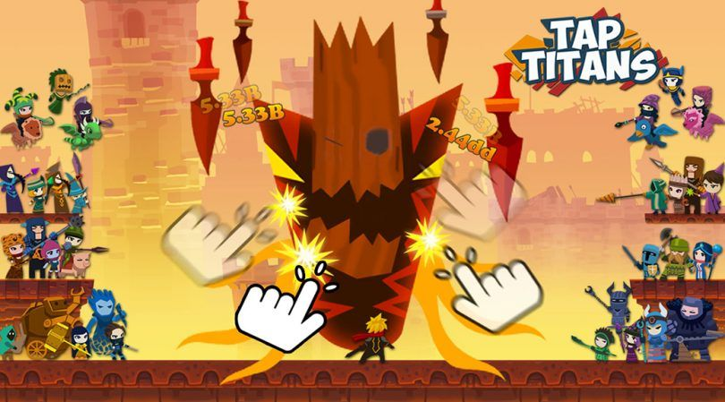

Ideas and concepts:

Rapid tapping to build up score to rival the other player. Rapid tapping combined with timed hits to score bonus points. The player taps on parts of the screen to score combos and points. The faster the tapping the bigger the build up of score. Players will do this turn at a time and then their scores will be compared, highest wins.

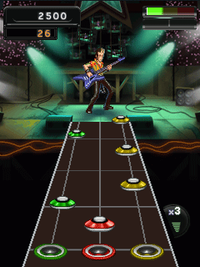

A rhythm based game where the players take it in turn to timed taps in sync with a set oncoming obstacle, much like guitar hero and other games similar. The challenge will come from the timing of the taps and the growing difficulty of the course as time increases, so will the speed of the level and will therefore test the reflexes and stamina of the player.

Each player will take it in turns to race their character through rings that score them points, whilst avoiding negative types of rings like electric shock rings and fire rings and fly into positive rings like green and red or golden rings that double the score of rings for 10 seconds or something along those lines.The courses will be the same to maintain symmetrical gameplay and the players will take it turns to tap the screen of the phone to move in a similar way to flappy bird.